Physics Stage 2: Nuclear Physics Test 2010.

Name: _____________MARKING GUIDE________________ (40 marks)

- Within a nuclear reactor, uranium-235 is bombarded by a neutron to split into two daughter products also emitting two neutrons. Part of the nuclear equation is shown below.

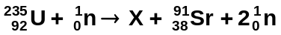

  - Write the nuclide for the missing daughter product labelled X. 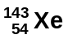 1 mark

  - What is the atomic and mass numbers of the daughter product:

Mass number __143___ 1 mark Atomic number ____54____ 1 mark

- In terms of the properties of alpha and beta radiation, explain why alpha radiation cannot penetrate paper but beta radiation can. (4 marks)

Alpha is a positive large, heavy particle that is slow moving. 1 mark

When it hits another particle, it is attracted to the negative electrons and quickly stopped as it hits the particle 1 mark

Beta is a negative electron, small size and mass which moves very fast. 1 mark

Rebounds off other particles due outer negative electrons so travels further 1 mark

- For an atomic bomb to explode the amount of uranium-235 must reach critical mass and then the fission reaction created from a neutron induced chain reaction becomes uncontrollable. What is a neutron induced chain reaction and why does it need critical mass to explode?
(4 marks)

Neutron induced chain reaction is one in which a neutron strikes the U-235 causing the nucleus to become unstable and to break up (decay) producing daughter products and an average of three neutrons. (1 mark)

These neutrons themselves strike other U-235 causing more decay and a continuation of the chain reaction. (1 mark)

Critical mass is when the mass of the U-235 is such that the neutrons from the chain reaction remain within the material causing further chain reactions. (1 mark)

With lesser masses, many of the neutrons escape the material and are unavailable to continue the chain reaction. (1 mark)

- A radioactive isotope has a count of 3.85 x 10³ decays in one hour. Calculate the activity of the source. (2 marks)

activity is counts per second so

A = 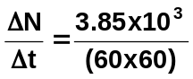 (1 mark)
= 1.07 Bq (1 mark)

- Calculating the binding energy per nucleon in MeV of the helium-3 atom given the mass of He-3 = 5.00 x 10⁻²⁷ kg. (4 marks)

He-3 = 2 protons and 1 neutron (3 nucleons)

m_{d} = 5.00 x 10⁻²⁷ - [(2 x 1.67 x 10⁻²⁷) + 1.68 x 10⁻²⁷]
= 0.02 x 10⁻²⁷ kg (1 mark)

= 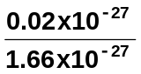 = 0.012 u per atom (1 mark)

= 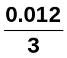 = 4.016 x 10⁻³ u per nucleon (1 mark)
4.016 x 10⁻³ x 931
= 3.74 MeV per nucleon (1 mark)

- If the original activity of a sample is 42.0 kBq and it has a half-life of 4.00 days, how much will be left after 12.0 days? (3 marks)

A₀ = 42.0 kBq A = A₀ (0.5)^{n}
Half-life = 4.00 days = 42.0 (0.5)³ 1 mark
Time = 12 days = 42.0 x 0.125
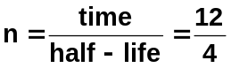 A = 5.25 kBq (3sf) 1 mark
n = 3 (1 mark)

- A radiation source and a detector can be used to measure the thickness of very thin aluminium foil during manufacture. Select, from the table, a suitable radioisotope to be used as a radiation source for this industrial process.

Radioisotope | Most Useful Radiation Emitted | Half-Life
Americium-241  Cesium-137  Cobalt-60  Iodine-131  Radium-223  Strontium-90 | alpha  gamma  gamma  beta  alpha  beta | 432 years  30 years  5.27 days  8.04 days  11.4 years  29 years

Choice: _______Strontium-90_____________ (1 mark)
Reason for choice: (3 marks)
Beta only radiation that can pass through aluminium but be affected by the thickness would be beta. (1 mark)

Alpha wouldn’t pass through any thickness and gamma is unaffected by thin aluminium. (1 mark)

Beta safe for humans so use one with longest half-life to reduce cost therefore use strontium-90 (1 mark)

- The forming of a new element during radioactive decay is called transmutation. Explain why emitting alpha and beta radiation causes a transmutation but emitting gamma radiation does not.
(3 marks)

When alpha radiation is emitted, two protons and two neutrons are remove so the number of protons decreases and the atom is now a lower element on the periodic table.

When beta radiation is emitted, a neutron breaks down into a proton and a beta particle. The atom now has an additional proton so is now a higher element on the periodic table.

Gamma radiation, on the other hand, is an electromagnetic wave and a form of energy. A change in energy doesn’t affect the number of protons so the atom stays the same element.

- A miner in a uranium mine is unaware that he is breathing in radon-222 gas, an alpha emitter. The gas has a very long half life with an activity of 3.40kBq which will be unchanged during his time in the mine. Each decay of the isotope releases 3.8 x 10⁻¹² J of energy into the body and that the radioisotope is not eliminated from the body as it settles into the tissue of his lung. After a month the gas is discovered and the mine closed (assume a month is 30 days).

- Calculate the total energy the miner absorbed into his lungs during this time. (2 marks)

3.4 x 10³ (activity) x 3.8 x 10⁻¹² (energy per decay) x 30 x 24 x 60 x 60 (time in s))
(1 mark)
energy = 3.4 x 10³ x 3.8 x 10⁻¹² x 2592000
energy = 0.03349 J
energy = 0.033 J (1 mark)

- Calculate the absorbed dose he received in one month if he has a mass of 75 kg. (If you were unable to obtain a value for (a) above use 0.035 J) (2 marks)

absorbed dose = 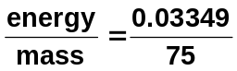 (1 mark)

absorbed dose = 4.47 x 10⁻⁴ Gy (1 mark)

(Alternative answer: 4.67 x 10⁻⁴ Gy)

- Calculate the dose equivalent if the alpha radiation has a quality factor of 20. (2 marks)

dose equivalent = absorbed dose x 20 (1 mark)
dose equivalent = 4.47 x 10⁻⁴ x 20
dose equivalent = 8.93 x 10⁻³ Sv (1 mark)

(alternative answer from (b) above 9.33 x 10⁻³ Sv)

- Should the miner be concerned about his exposure? Explain. (2 marks)

No (1 mark)
This is a very small amount so will cause no harm (1 mark)

NOTE: If student gets the units wrong,
deduce 1 mark only from possible 8 marks

- Determine the half-life of the substance from the graph.

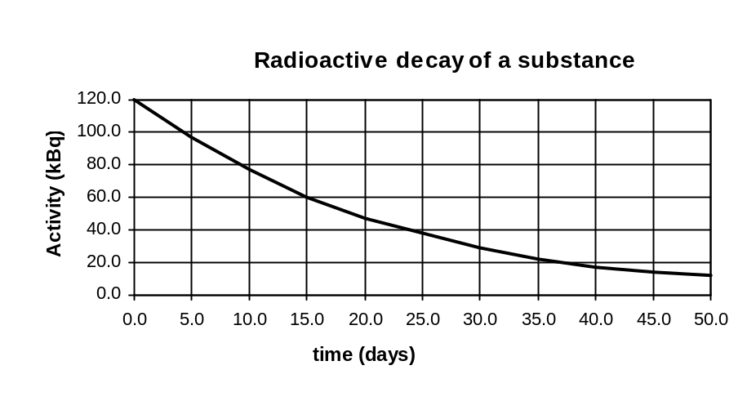

Half-life = 15 days 1 mark

  - When Pu-238 (atomic number 94) is bombarded with a neutron, fission occurs to form Sn-128 (atomic number 50), Ru-108 (atomic number 44) and some neutrons.

a. Complete the nuclear equation showing the number of neutrons released. (1 mark)

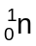 + 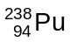 → 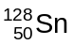 + 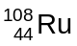 + __3__ 1 mark

b. How much energy is released per reaction using the information on your data sheet and below. (3 marks)

Pu-238 = 396.82 x 10⁻²⁷ kg
Sn-128 = 212.33 x 10⁻²⁷ kg
Ru-108 = 179.13 x 10⁻²⁷ kg

+ 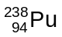 → + 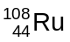 + 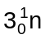

m_{d} = (1.68 x 10⁻²⁷ + 396.82 x 10⁻²⁷) - [212.33 x 10⁻²⁷ + 179.13 x 10⁻²⁷ + (3 x 1.68 x 10⁻²⁷]
1 mark
= 3.985 x 10⁻²⁵ - 3.965 x 10⁻²⁵
= 2.00 x 10⁻²⁷ kg 1 mark

E = mc²
= 2.00 x 10⁻²⁷ x (3 x 10⁸)²
= 18.0 x 10⁻¹⁰ J 1 mark

